1. Name the sub-category whose profit value is least (lowest) in the year 2022
2. Who are 25th, 50th and 100th customers from top with respect to sum of sales in 2021?
3. Show the Top 3 products with respect to sum of quantity under each segment (Total 9 products) in West region.
4. Create new order date (e.g. if current year is 2023 then make sure new order date should have 2023) and show below columns in the text table.
   * Year
   * Quarter
   * Month
   * SUM(Sales)
   * YTD Sales
   * QTD Sales
   * MTD Sales
5. Show sub-category and region wise sum of profit in KPI indicator table as shown in below image. Use green circle for positive profit value and red circle for negative profit value.

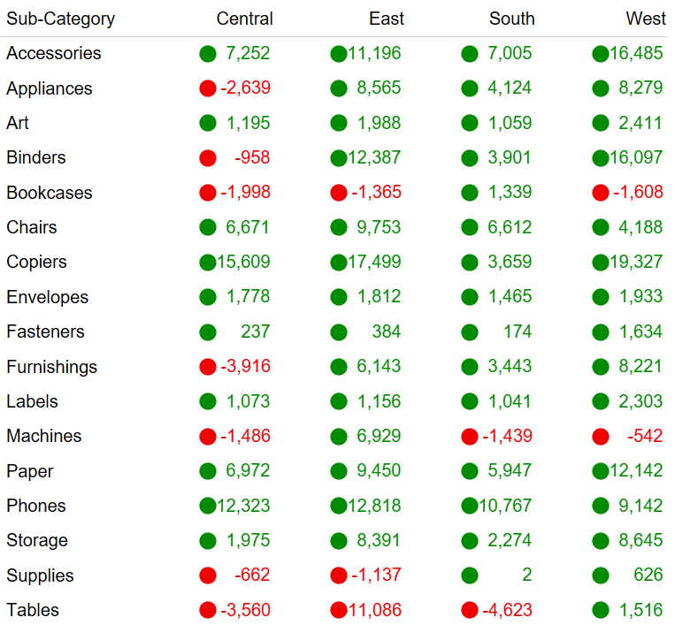

1. Create a table with customer name, first order date and last order date for each customer.
2. Create a pie chart showing Top 50 customers Vs Other customers with respect to sum of sales shown in below image.

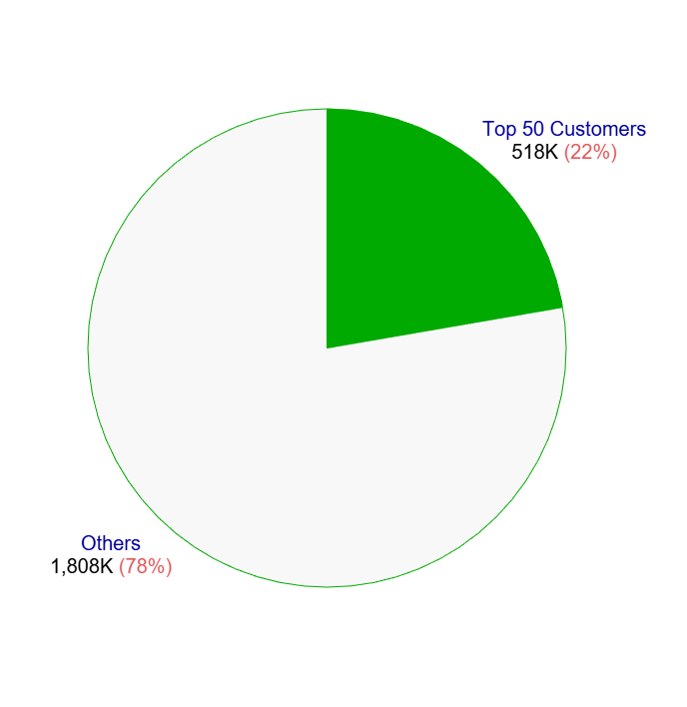

1. Create a table with columns such as category, sub-category in rows and region in columns with total sales and total profit shown for each region along with grand total and percent of pane total sorted by sum of sales in descending manner as shown in below image.

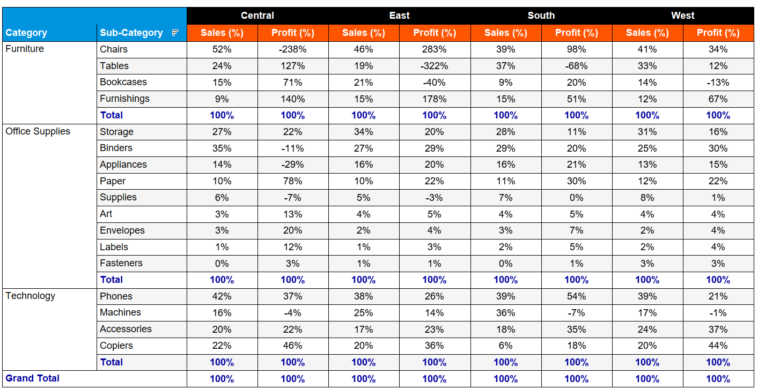

1. Create the parameter with name as View by. Use three values in parameter i.e. Region, Category and Sub-category. If user selects any value then show the sum of sales with respect to the value chosen in parameter as a bar chart. E.g., If user selects category then show category wise sales. Make sure to edit the worksheet title w.r.t. View by value.
2. Show the Top N customers with respect to sum of quantity. The value N should be user-entered. Edit the title accordingly.
3. Answer in brief.
   * What is Replace References in tableau?
   * How to handle the NULL values for measures?
4. Analyse the purchasing capacity of customers by creating the bins of sales with bins size as 10. Show the bar chart of count of sales vs bins. The labels outside the bar chart should be shown in this format: 1,398 *(13.7%)*. Note that if any count of sales value is blank/null value then the bar chart should show 0
5. Show the country wise, region wise, state wise and city wise sum of sales in a table by creating the hierarchy starting with country. Colour the sum of sales based on following conditions.
   * Green: Values > 100000
   * Orange: Between 10000 and 100000
   * Red: Values < 10000
6. Make a group of Acco, 3M, Samsung, Apple, Xerox products. (For remaining products include in others folder). Display each group as average discount percentage.
7. Show the average sales for each year and each month. Show the overall average sales of all the months using reference line and highlight those months for which the sales value is more than overall average sales value.
8. Show the scatter chart between sum of sales and sum of profit for all the orders. Show the trend line and write down the observations using Annotate option.
9. Create a donut chart of orders distribution in different ship modes i.e. Show total unique orders in the inner circle and ship mode wise unique orders in outer circle. Create the donut chart in below fashion with exact formatting.

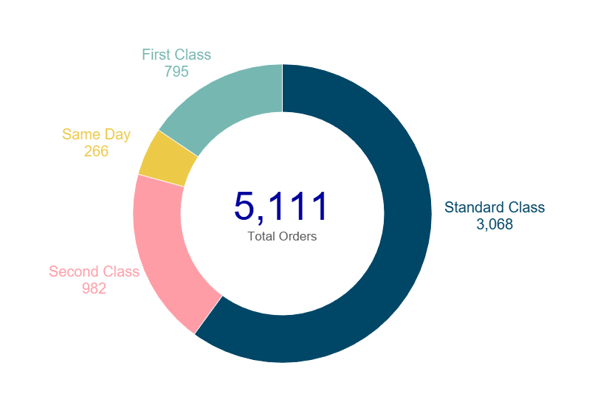

1. Create a dashboard on Superstore Analytics as shown in below figures. The formatting / labelling / spacing / alignment should be the same as used in the charts. Read this completely.

*Notes:*

* + The worksheet titles, KPI titles represent which dimensions/measures are required in respective places.
  + Make sure to use New Order Date in place of existing Order Date dimension for doing any date calculations or adding the Year filter on top.
  + Add appropriate tooltips everywhere.
  + Add the Year(New Order Date), Region and Category filters on top. All filters must be in multiple values dropdown mode. These filters should be applied to all the worksheets used in dashboard 1 and dashboard 2. Make sure Year filter should not be applied to current year sales, previous year sales and YoY growth % as these values are for current year and previous year. Make sure to apply filters on table in dashboard 2.
  + Initially filters are in hidden state. If you click on show filters icon the filters need to open. When you click on hide filters icon the filters should hide back.
  + Apply filter actions keeping bar chart, donut chart and Top 5 bar chart as source and all the worksheets as target.
  + Make sure to show top 5 products w.r.t. sum of sales every time irrespective of any filter action values you select or any dropdown filter values you select.
  + On the click of Detail Report tab, the dashboard 2 should open and on the click of Sales Analytics tab, dashboard 1 should open. Use appropriate tooltips.
  + You can find the dashboard logo and filters logo attached below.
  + Dashboard logo:



* Show Filters Icon:



* Hide Filters Icon:



**Dashboard 1 (Sales Analytics):**

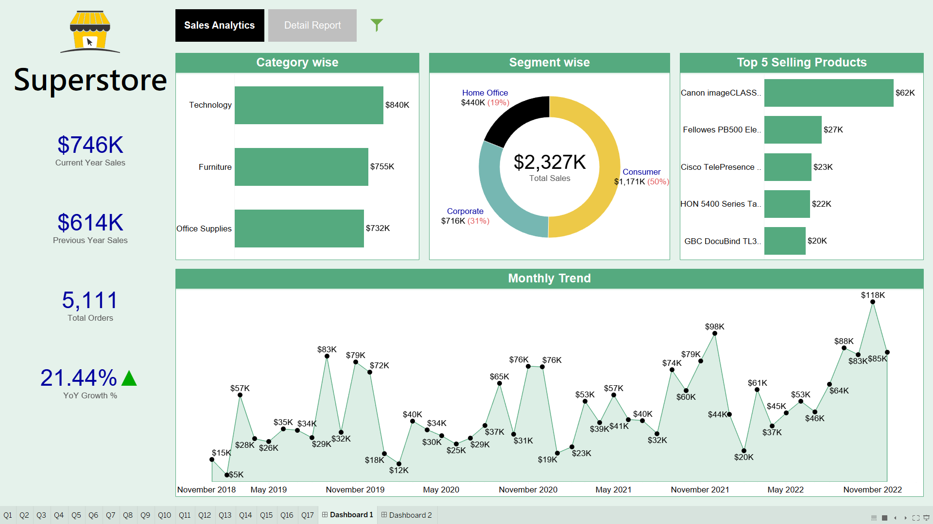

**Dashboard 2 (Detail Report):**

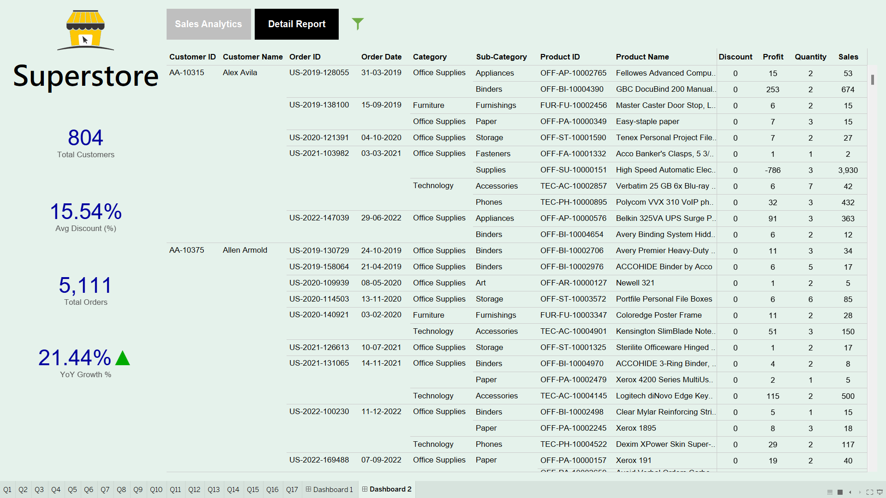

1. Use Netflix dataset and find out country wise shows and total cost for each country. Show the stacked bar chart for the same as shown in below image.

